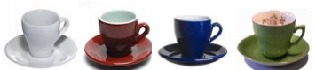
Aunt Jane had been to a jumble sale and bought a whole lot of cups and saucers - she's having many visitors these days and felt that she needed some more. You are staying with her and when she arrives home you help her to unpack the cups and saucers.
There are four sets: a set of white, a set of red, a set of blue and a set of green. In each set there are four cups and four saucers. So there are 16 cups and 16 saucers altogether.
Just for the fun of it, you decide to mix them around a bit so that there are 16 different-looking cup/saucer combinations laid out on the table in a very long line.
So, for example:
a) there is a red cup on a green saucer but not another the same although there is a green cup on a red saucer;
b) there is a red cup on a red saucer but that's the only one like it.
There are these 16 different cup/saucer combinations on the table and you think about arranging them in a big square. Because there are 16 you realise that there are going to be 4 rows with 4 in each row (or if you like, 4 rows and 4 columns).
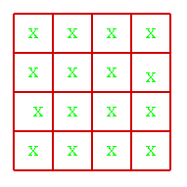

So here is the challenge to start off this investigation. Place these 16 different combinations of cup/saucer in this 4 by 4 arrangement with the following rules:-
1) In any row there must only be one cup of each colour;
2) In any row there must only be one saucer of each colour;
3) In any column there must only be one cup of each colour;
4) In any column there must be only one saucer of each colour.
Remember that these 16 cup/saucers are all different so, for example, you CANNOT have a red cup on a green saucer somewhere and another red cup on a green saucer somewhere else.

